***Logic Specification Template***

|  |  |  |  |
| --- | --- | --- | --- |
| **Student** | Gerardo Galan Garzafox | **Program** | 4 |

|  |  |
| --- | --- |
| **Class Name** | IO |

|  |  |
| --- | --- |
| **Method Name** | read() |

|  |  |
| --- | --- |
| **Parameters** |  |
|  | void |
|  |  |
|  |  |
|  |  |

**Include the image of the activity diagram created for the program:**

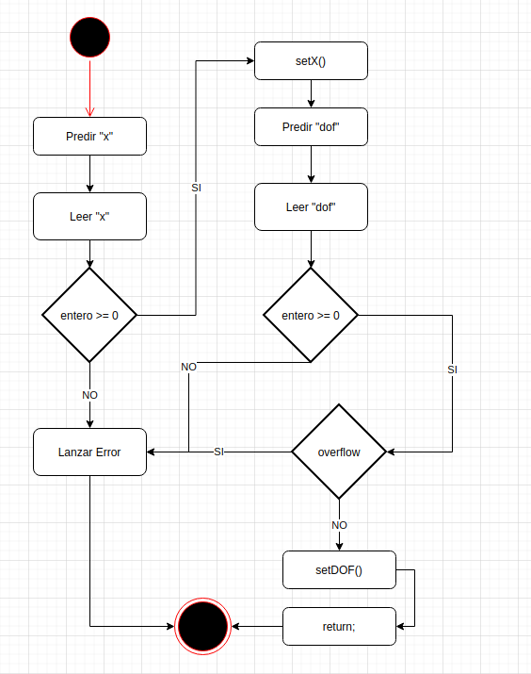

|  |  |
| --- | --- |
| **Class Name** | IO |

|  |  |
| --- | --- |
| **Method Name** | print() |

|  |  |
| --- | --- |
| **Parameters** |  |
|  | void |
|  |  |
|  |  |
|  |  |

**Include the image of the activity diagram created for the program:**

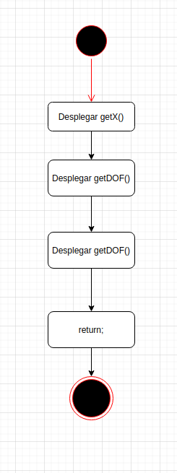

|  |  |
| --- | --- |
| **Class Name** | Calc |

|  |  |
| --- | --- |
| **Method Name** | gamma(long double):long double |

|  |  |
| --- | --- |
| **Parameters** | x:long double |
|  |  |
|  |  |
|  |  |
|  |  |

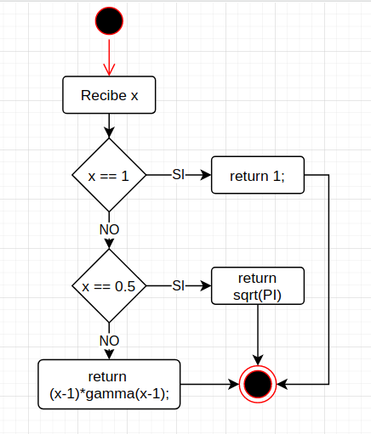

|  |  |
| --- | --- |
| **Class Name** | Calc |

|  |  |
| --- | --- |
| **Method Name** | tDistribution(long double):long double |

|  |  |
| --- | --- |
| **Parameters** | x:long double |
|  |  |
|  |  |
|  |  |
|  |  |

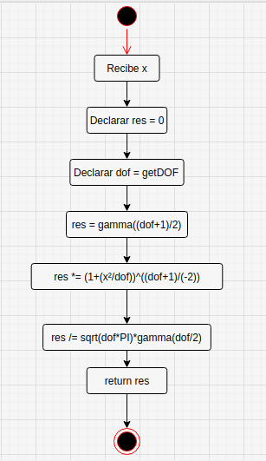

|  |  |
| --- | --- |
| **Class Name** | Calc |

|  |  |
| --- | --- |
| **Method Name** | simpson():long double |

|  |  |
| --- | --- |
| **Parameters** | none |
|  |  |
|  |  |
|  |  |
|  |  |

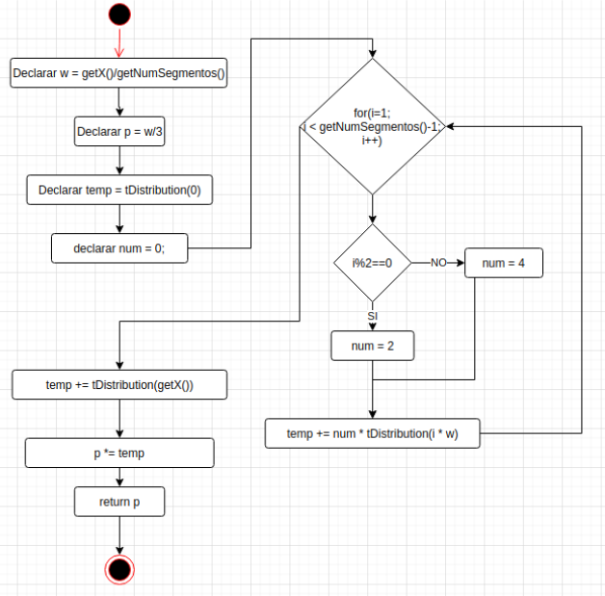

|  |  |
| --- | --- |
| **Class Name** | Calc |

|  |  |
| --- | --- |
| **Method Name** | approximate():long double |

|  |  |
| --- | --- |
| **Parameters** | none |
|  |  |
|  |  |
|  |  |
|  |  |

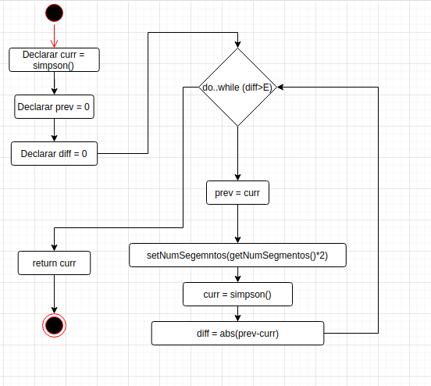

|  |  |
| --- | --- |
| **Class Name** | Main |

|  |  |
| --- | --- |
| **Method Name** | main():int |

|  |  |
| --- | --- |
| **Parameters** | none |
|  |  |
|  |  |
|  |  |
|  |  |

